Case Study Report



**Tech Saksham**

Data Analytics with Power BI

**INVENTORY AND SALES ANALYSIS OF DEPARTMENTAL STORE**

**SRI KRISHNA ADITHYA COLLEGE OF ARTS AND SCIENCE**

|  |  |
| --- | --- |
| **NM ID** | **NAME** |
| C76AFF0DA45B8D792844DEB6E7817CAF | SREE DEV. A. K |

|  |  |
| --- | --- |
|  |  |
|  | Trainer Name: UMAMAHESWARI. R |
|  | Master Trainer: UMAMAHESWARI. R |

**ABSTRACT**

In the realm of retail, effective inventory and sales analysis are paramount for departmental stores to thrive. This project, "Inventory and Sales Analysis of Departmental Store," harnesses the power of PowerBI to delve into the intricacies of inventory management and sales trends. By leveraging real-time data captured at the point of sale, this analysis provides insights into product performance, inventory turnover, and revenue generation. Through interactive dashboards and comprehensive reports, stakeholders gain actionable intelligence to optimize inventory levels, identify top-selling products, and enhance overall profitability.

**INDEX**

|  |  |  |
| --- | --- | --- |
| **Sr. No.** | **Table of Contents** | **Page No.** |
| 1 | Chapter 1: Introduction | 1 |
| 2 | Chapter 2: Services and Tools Required | 4 |
| 3 | Chapter 3: Project Architecture | 6 |
| 4 | Chapter 4: Modeling and Result | 7 |
| 5 | Conclusion | 9 |
| 6 | Future Scope | 10 |
| 7 | References | 11 |
| 8 | Links | 12 |

**CHAPTER 1**

**INTRODUCTION**

* 1. **Problem Statement**

Departmental stores face challenges in effective inventory management and sales data analysis due to traditional manual methods. These methods are time-consuming and lack real-time insights, leading to inefficient stock management, missed sales opportunities, and suboptimal profitability. The complexity of managing inventory across multiple departments and locations further complicates the process. Real-time analysis of sales data is crucial for identifying trends and addressing potential issues. Relying solely on historical data can be limiting. Technological advancements offer solutions, such as integrated inventory management systems powered by artificial intelligence and machine learning algorithms, which provide real-time visibility into stock levels, demand forecasts, and inventory performance. These tools can also uncover hidden patterns and forecast sales trends. The integration of cloud-based platforms and mobile applications enhances operational efficiency.

* 1. **Proposed Solution**

The proposed solution uses Microsoft Power BI to revolutionize inventory management and sales analysis in departmental stores. Power BI is a robust data visualization and analytics tool that transforms raw data into actionable insights. It integrates with existing point-of-sale systems, aggregating real-time data on sales transactions, inventory levels, and customer interactions. Power BI generates interactive dashboards and reports, providing a comprehensive overview of key metrics. Store managers can use these dashboards to monitor inventory levels, identify fast-moving products, and anticipate stockouts or overstock situations. Power BI's advanced analytics enable predictive modeling, forecasting, inventory planning, procurement decisions, and collaboration across departments, supporting business growth and expansion initiatives.

* 1. **Feature**
* Real-Time Inventory Analysis
* Sales Trend Analysis
* Product Performance Metrics
* Inventory Turnover Ratios
  1. **Advantages**

**Enhanced Inventory Management:**

* Departmental stores utilize automated systems, demand forecasting, just-in-time practices, and dynamic replenishment processes for improved inventory management, reducing manual errors and stockouts.

**Improved Sales Forecasting:**

* Improved sales forecasting utilizes data analytics and predictive modeling to predict future sales performance, integrating data from various sources and conducting scenario analysis for informed retailers.

**Optimal Stock Levels:**

* Inventory optimization techniques, dynamic management, and collaborative planning ensure optimal stock levels, meet customer demand, minimize costs, avoid stockouts, and reduce lead times through real-time adjustments.

**Increased Profitability:**

* Effective inventory management and sales forecasting strategies enhance profitability by reducing costs, optimizing revenue, and enhancing customer satisfaction, leading to lower carrying costs and improved margins.
  1. **Scope**

This project aims to improve inventory management and sales analysis processes in departmental stores by utilizing PowerBI dashboards and reports. The project uses PowerBI to gather, analyze, and visualize data related to inventory and sales, providing real-time and historical insights. This information is crucial for store managers, inventory controllers, and executives, who can make informed decisions about inventory replenishment, pricing strategies, and promotional activities. The project also lays the groundwork for future enhancements, including predictive analytics and advanced inventory optimization techniques. These tools can anticipate future demand patterns, identify potential risks, and adjust inventory levels and pricing strategies. The project aims to empower stakeholders at all levels to make data-driven decisions, driving operational efficiency, boosting profitability, and ensuring long-term success in the retail industry.

**CHAPTER 2**

**SERVICES AND TOOLS REQUIRED**

**2.1 Services Used**

* **Data Collection and Storage Services:** Modern information systems rely on data collection and storage services for efficient data management, including source identification, transformation, real-time ingestion, database systems, data warehousing, and interoperability.
* **Real-Time Data Processing Services:** Real-time data processing services, utilizing technologies like Apache Kafka and Amazon Kinesis, are crucial for businesses to stay competitive in the digital landscape.

**Top of Form**

* **Data Visualization Services:** Data visualization services are essential for organizations to visually represent raw data, aiding in understanding patterns and effectively communicating complex information.

**2.2 Tools and Software used**

1. **Power BI**: Microsoft created the Power BI package of business analytics tools, which allows users to display and analyze data. Connecting to several data sources, transforming data, producing interactive reports and visualizations, and disseminating insights throughout the company are all made possible by it. Because of its user-friendly design, Power BI is available to both data specialists and business users.
2. **Power Query**: Power Query is a tool for connecting data that lets users find, join, aggregate, and clean up data from many different sources. Numerous Microsoft products, like as Excel and Power BI, have it integrated. Users may quickly import data from databases, files, webpages, and other sources, process the data, put it into their analysis environment, and carry out data transformations and purification tasks using Power Query.
3. **Power BI Desktop**: The main writing tool for Power BI reports and dashboards is a free desktop program called Power BI Desktop. It offers an extensive feature set for report design, data modeling, and visualization. With a drag-and-drop interface, users can develop interactive visualizations, establish links between tables, connect to numerous data sources, and publish their reports to the Power BI Service.
4. **Power BI Service**: Microsoft offers Power BI Service, commonly referred to as Power BI online, as a cloud-based platform for managing, sharing, and working together on Power BI content. Users can publish Power BI dashboards and reports to the cloud, where they can be accessed by external parties or by other members of their business (if set). Access authorization management, data refresh scheduling, data-driven alert setup, and online report viewing are all made possible by Power BI Service.
5. **Power BI Mobile**: Power BI Mobile is a collection of mobile apps for Windows, iOS, and Android smartphones that increase the accessibility of Power BI content for users who are always on the go. Users using Power BI Mobile may view interactive visualizations, explore data, and receive data-driven alerts and notifications in addition to being able to access their Power BI reports and dashboards from smartphones and tablets. The mobile apps offer a dynamic user experience for viewing and engaging with Power BI content on mobile devices and are geared for touch interactions.

**CHAPTER 3**

**PROJECT ARCHITECTURE**

**3.1 Architecture**

**USER FRONTEND BACKEND**

|  |  |  |
| --- | --- | --- |
|  | **HTML 5** | **NODEJS 14.0**  **Database** |

Here’s a high-level architecture for the project:

1. **Data Collection:** Transactional data from sales, inventory, and other relevant sources within the departmental store is collected in real-time. This includes data from barcode scanners, POS systems, and inventory management systems.
2. **Data Storage:** The collected data is stored in a database for processing and analysis. Azure SQL Database or AWS RDS can be utilized for this purpose, ensuring efficient storage and retrieval of data.
3. **Data Processing:** Real-time data processing is performed using Power BI's built-in capabilities or additional services like Azure Stream Analytics or AWS Kinesis Data Analytics. This involves cleaning, transforming, and aggregating the data to derive meaningful insights.
4. **Data Modeling:** Machine learning algorithms may be applied to the processed data to predict sales trends, identify patterns, and optimize inventory management. This could involve tools like Azure Machine Learning or custom algorithms developed using Python or R.
5. **Data Visualization**: Power BI is used to create interactive dashboards and reports that visualize the analyzed data. This includes sales performance metrics, inventory levels, trend analysis, and customer segmentation.
6. **Data Access:** The Power BI dashboards and reports can be accessed through various platforms including Power BI Desktop, Power BI Service (online), and Power BI Mobile app. This enables stakeholders to view and interact with the analysis results in real-time.

This architecture provides a comprehensive solution for inventory and sales analysis, enabling the departmental store to make data-driven decisions and optimize operations. However, it's important to customize the architecture based on specific requirements, existing infrastructure, and compliance with data privacy regulations.

**CHAPTER 4**

**MODELING AND RESULT**

**Manage relationship**

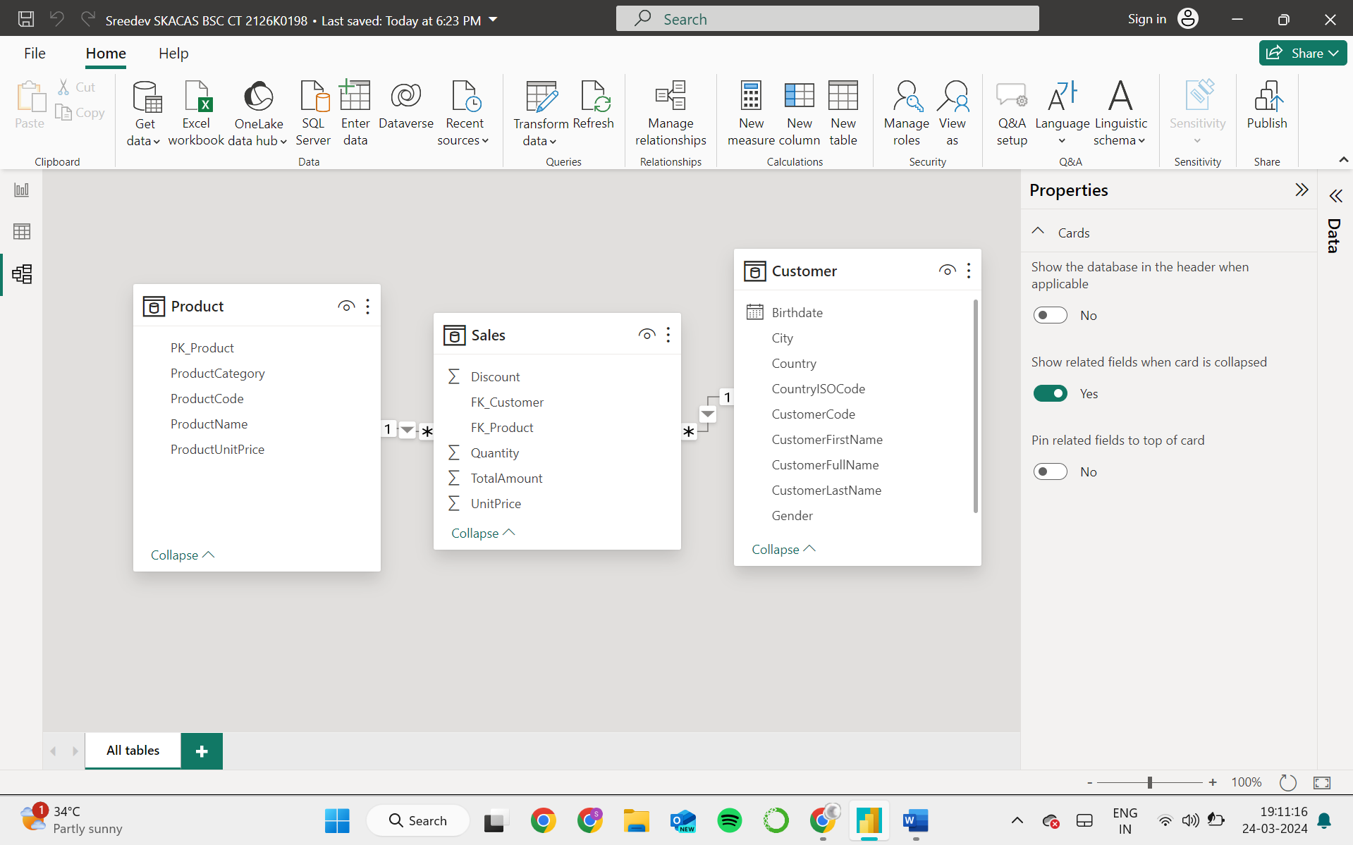

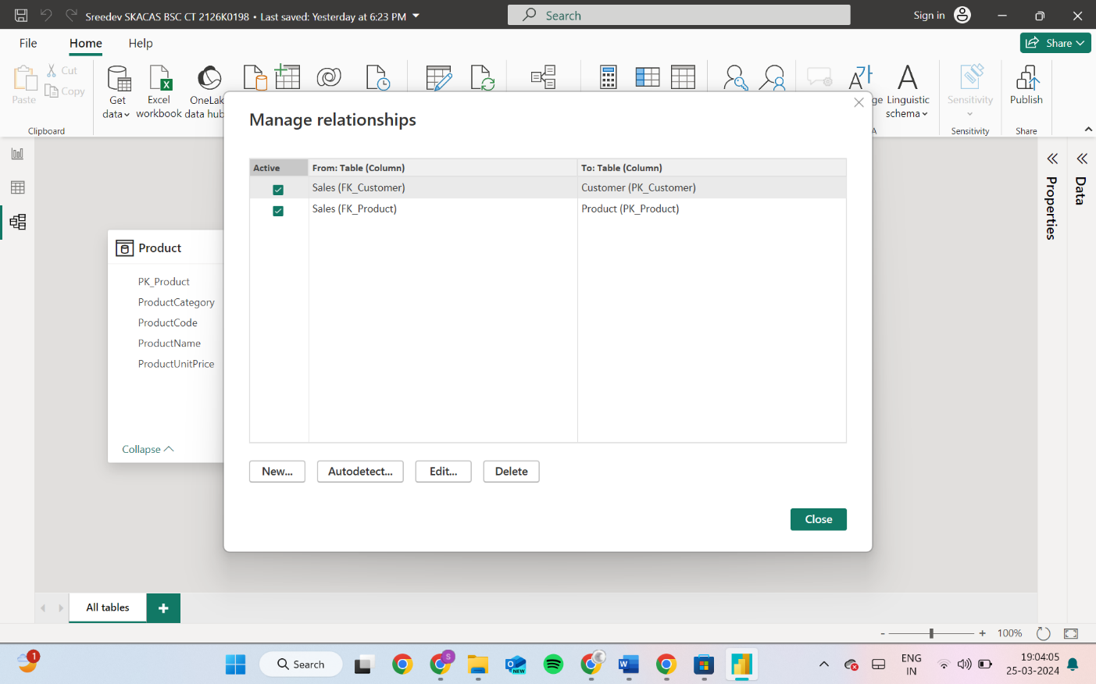

**EDIT RELATIONSHIP**

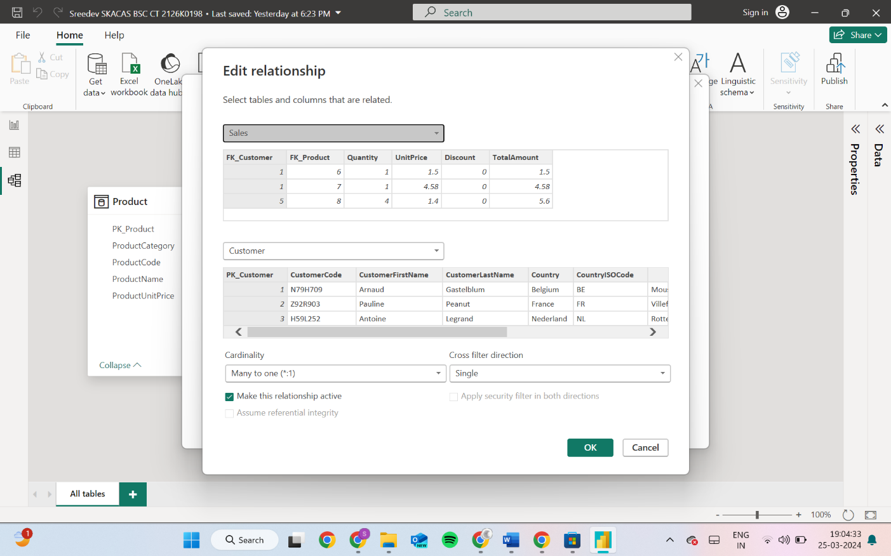

**Dashboard**

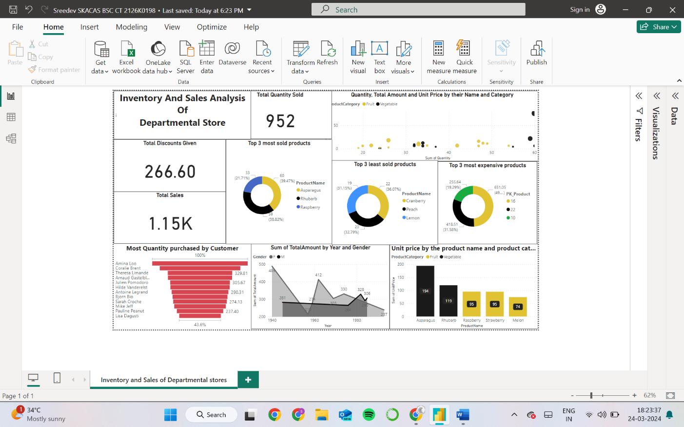

**CONCLUSION**

The project “Real-Time Analysis of Bank Customers” using PowerBI has successfully demonstrated the potential of data analytics in the banking sector. The real-time analysis of customer data has provided valuable insights into customer behavior, preferences, and trends, thereby facilitating informed decision-making. The interactive dashboards and reports have offered a comprehensive view of customer data, enabling the identification of patterns and correlations. This has not only improved the efficiency of data analysis but also enhanced the bank’s ability to provide personalized services to its customers. The project has also highlighted the importance of data visualization in making complex data more understandable and accessible. The use of PowerBI has made it possible to present data in a visually appealing and easy-to-understand format, thereby aiding in better decision-making.

**FUTURE SCOPE**

The project aims to enhance inventory management and sales analysis in departmental stores by integrating advanced technologies and methodologies. This includes an increase in predictive analytics capabilities, which will enable proactive decision-making and resource allocation. Machine learning methodologies will be used to continuously refine predictive models and adapt to market dynamics. Advanced inventory optimization techniques will optimize inventory levels, procurement costs, and customer demand, maximizing profitability while minimizing wastage. The integration of IoT devices and AI will provide real-time data on inventory levels, shelf life, and environmental conditions, allowing for better visibility and control. AI-driven analytics will provide actionable insights, enhancing operational efficiency and customer satisfaction.

**REFERENCES**

* "Retail Analytics: The Secret Weapon" by Emmett Cox - This book provides insights into the importance of analytics in the retail industry, including inventory management, sales analysis, and customer behavior tracking.
* "The Data Warehouse Toolkit: The Definitive Guide to Dimensional Modeling" by Ralph Kimball and Margy Ross - This classic book offers comprehensive guidance on building data warehouses and dimensional modeling, which are essential for conducting effective inventory and sales analysis.
* "Sales Analysis Techniques: Using Excel and Power BI" by Matt Allington - This practical guide demonstrates how to perform sales analysis using Excel and Power BI, with step-by-step instructions and real-world examples.
* "Power BI Essentials: An End-to-End Guide to Understanding Power BI" by Mynda Treacy and Matt Allington - For a deeper understanding of Power BI and its application in retail analytics, this book offers comprehensive coverage of Power BI features and functionalities

**LINK**

https://github.com/Dev280703/INVENTORY-AND-SALES-ANALYSIS-OF-DEPARTMENTAL-STORE.git